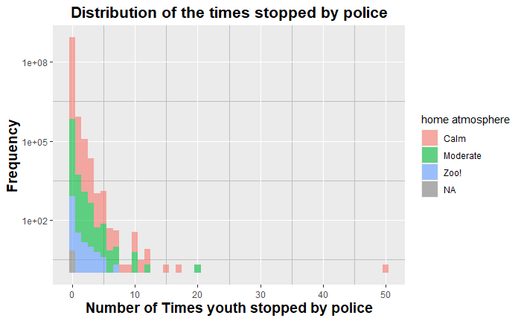

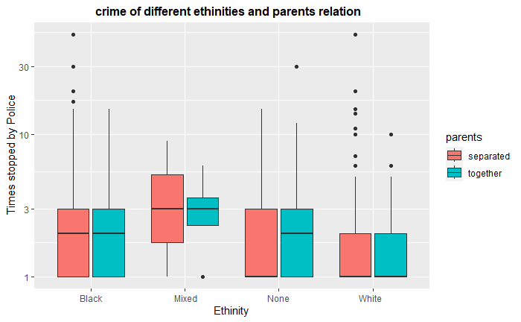

Ever tried marijuana?



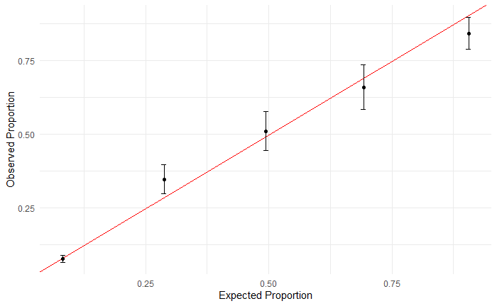

Significant parameters:

Friends tried marijuana

Age of friends you spend time with?

How often knows what youth spends money on?

How often PCG drinks alcohol?

Ever arrested or taken into custody by police?

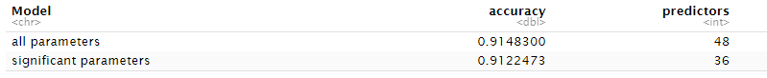

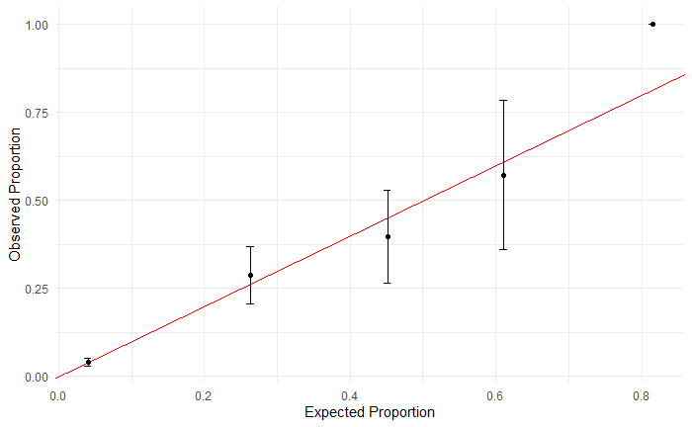

Significant variables:

Gotten into a serious physical fight?

If I fight with someone, it's nobody else's business

How often knows what youth does during free time?

Number of times stopped by police

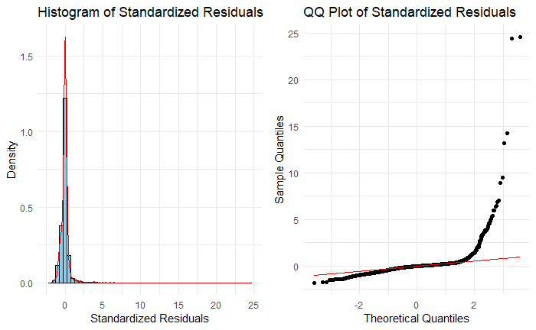

Robust:

R2 training = 0.2691838

R2 test = 0.3054683

Significant variables:

Deliberately damaged property that didn't belong to you

Gotten into a serious physical fight

How often police clearly explained why they stopped you/them?

Frequency saw person attacked with weapon in past year

Youth lies or cheats

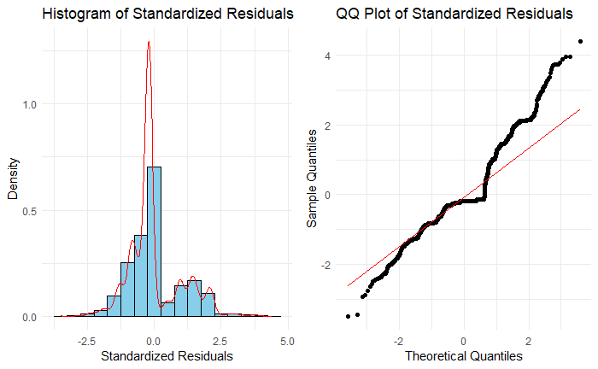

Robust:

R2 training = 0.341

R2 test = 0.346

Lasso: R2=0.354

Significant variables:

Youth is cruel, bullies, or shows meanness to others

Youth destroys things belonging to family or others

Youth is disobedient

Youth doesn't seem to feel guilty after misbehaving

How close do you feel to youth?

Had another baby, adopted, or expecting since last int?